DATABASE SPECIFICATIONS (PerioDx)

|  |  |  |  |
| --- | --- | --- | --- |
| **Revision** | **Written By** | **Prepared For** | **Document Type** |
| 1.0 | Phuoc Nguyen | Php - saas | Technical Note |

# Database schema

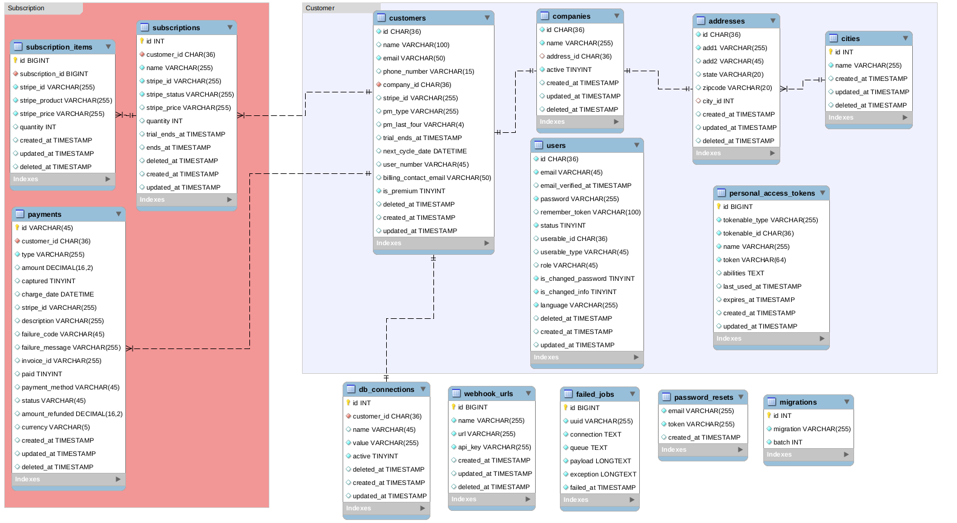

# 

# Entities

**Users**

|  |  |  |
| --- | --- | --- |
| **No.** | **Attribute**  **Thuộc tính** | **Type**  **Loại** |
| 1 | id | UUID |
| 2 | email | VARCHAR |
| 3 | email_verified_at | TIMESTAMP |
| 4 | password | VARCHAR |
| 5 | remember_token | VARCHAR |
| 6 | status | TINYINT |
| 7 | last_login_at | DATETIME |
| 8 | userable_id | UUID |
| 9 | userable_type | VARCHAR |
| 10 | role | VARCHAR |
| 11 | language | VARCHAR |
| 12 | is_changed_password | TINYINT |
| 13 | is_changed_info | TINYINT |
| 14 | deleted_at | TIMESTAMP |
| 15 | created_at | TIMESTAMP |
| 16 | updated_at | TIMESTAMP |

**Cities**

|  |  |  |
| --- | --- | --- |
| **No.** | **Attribute**  **Thuộc tính** | **Type**  **Loại** |
| 1 | id | INT |
| 2 | name | VARCHAR |
| 3 | created_at | TIMESTAMP |
| 4 | updated_at | TIMESTAMP |
| 5 | deleted_at | TIMESTAMP |

**Addresses**

|  |  |  |
| --- | --- | --- |
| **No.** | **Attribute**  **Thuộc tính** | **Type**  **Loại** |
| 1 | id | UUID |
| 2 | add1 | VARCHAR |
| 3 | add2 | VARCHAR |
| 4 | state | VARCHAR |
| 5 | zipcode | VARCHAR |
| 6 | city_id | INT |
| 7 | created_at | TIMESTAMP |
| 8 | updated_at | TIMESTAMP |
| 9 | deleted_at | TIMESTAMP |

**Companies**

|  |  |  |
| --- | --- | --- |
| **No.** | **Attribute**  **Thuộc tính** | **Type**  **Loại** |
| 1 | id | UUID |
| 2 | name | VARCHAR |
| 3 | address_id | INT |
| 4 | active | TINYINT |
| 5 | created_at | TIMESTAMP |
| 6 | updated_at | TIMESTAMP |
| 7 | deleted_at | TIMESTAMP |

**Customers**

|  |  |  |
| --- | --- | --- |
| **No.** | **Attribute**  **Thuộc tính** | **Type**  **Loại** |
| 1 | id | UUID |
| 2 | name | VARCHAR |
| 3 | email | VARCHAR |
| 4 | phone_number | VARCHAR |
| 5 | company_id | INT |
| 6 | stripe_id | VARCHAR |
| 7 | pm_type | VARCHAR |
| 8 | pm_last_four | VARCHAR |
| 9 | trial_ends_at | TIMESTAMP |
| 10 | next_cycle_date | DATETIME |
| 11 | user_number | VARCHAR |
| 12 | billing_contact_email | VARCHAR |
| 13 | is_premium | TINYINT |
| 14 | deleted_at | TIMESTAMP |
| 15 | created_at | TIMESTAMP |
| 16 | updated_at | TIMESTAMP |

**Personal Access Tokens**

|  |  |  |
| --- | --- | --- |
| **No.** | **Attribute**  **Thuộc tính** | **Type**  **Loại** |
| 1 | id | BIGINT |
| 2 | tokenable_type | VARCHAR |
| 3 | tokenable_id | UUID |
| 4 | name | VARCHAR |
| 5 | token | VARCHAR |
| 6 | abilities | TEXT |
| 7 | last_used_at | TIMESTAMP |
| 8 | expires_at | TIMESTAMP |
| 9 | created_at | TIMESTAMP |
| 10 | updated_at | TIMESTAMP |

**DB Connections**

|  |  |  |
| --- | --- | --- |
| **No.** | **Attribute**  **Thuộc tính** | **Type**  **Loại** |
| 1 | id | UUID |
| 2 | tenant_id | UUID |
| 3 | name | VARCHAR |
| 4 | value | VARCHAR |
| 5 | active | TINYINT |
| 6 | created_at | TIMESTAMP |
| 7 | updated_at | TIMESTAMP |
| 8 | deleted_at | TIMESTAMP |

**Subscriptions**

|  |  |  |
| --- | --- | --- |
| **No.** | **Attribute**  **Thuộc tính** | **Type**  **Loại** |
| 1 | id | INT |
| 2 | tenant_id | UUID |
| 3 | name | VARCHAR |
| 4 | stripe_id | VARCHAR |
| 5 | stripe_status | VARCHAR |
| 6 | stripe_price | VARCHAR |
| 7 | quantity | INT |
| 8 | trial_ends_at | TIMESTAMP |
| 9 | ends_at | TIMESTAMP |
| 10 | deleted_at | TIMESTAMP |
| 11 | created_at | TIMESTAMP |
| 12 | updated_at | TIMESTAMP |

**Subscription Items**

|  |  |  |
| --- | --- | --- |
| **No.** | **Attribute**  **Thuộc tính** | **Type**  **Loại** |
| 1 | id | BIGINT |
| 2 | subscription_id | BIGINT |
| 3 | stripe_id | VARCHAR |
| 4 | stripe_product | VARCHAR |
| 5 | stripe_price | VARCHAR |
| 6 | quantity | INT |
| 7 | created_at | TIMESTAMP |
| 8 | updated_at | TIMESTAMP |
| 9 | deleted_at | TIMESTAMP |

**Payments**

|  |  |  |
| --- | --- | --- |
| **No.** | **Attribute**  **Thuộc tính** | **Type**  **Loại** |
| 1 | id | VARCHAR |
| 2 | customer_id | UUID |
| 3 | type | VARCHAR |
| 4 | amount | INT |
| 5 | currency | VARCHAR |
| 6 | captured | TINYINT |
| 7 | charge_date | DATETIME |
| 8 | stripe_id | VARCHAR |
| 9 | description | VARCHAR |
| 10 | failure_code | VARCHAR |
| 11 | failure_message | VARCHAR |
| 12 | invoice_id | VARCHAR |
| 13 | paid | TINYINT |
| 14 | payment_method | VARCHAR |
| 15 | status | VARCHAR |
| 16 | amount_refunded | INT |
| 17 | created_at | TIMESTAMP |
| 18 | created_at | TIMESTAMP |
| 19 | deleted_at | TIMESTAMP |

**Webhook Urls**

|  |  |  |
| --- | --- | --- |
| **No.** | **Attribute**  **Thuộc tính** | **Type**  **Loại** |
| 1 | id | BIGINT |
| 2 | name | VARCHAR |
| 3 | url | VARCHAR |
| 4 | api_key | VARCHAR |
| 5 | created_at | TIMESTAMP |
| 6 | updated_at | TIMESTAMP |
| 7 | deleted_at | TIMESTAMP |

**Password Resets**

|  |  |  |
| --- | --- | --- |
| **No.** | **Attribute**  **Thuộc tính** | **Type**  **Loại** |
| 1 | email | VARCHAR |
| 2 | token | VARCHAR |
| 3 | created_at | TIMESTAMP |

**Migrations**

|  |  |  |
| --- | --- | --- |
| **No.** | **Attribute**  **Thuộc tính** | **Type**  **Loại** |
| 1 | id | INT |
| 2 | migration | VARCHAR |
| 3 | batch | INT |

**Failed Jobs**

|  |  |  |
| --- | --- | --- |
| **No.** | **Attribute**  **Thuộc tính** | **Type**  **Loại** |
| 1 | id | BIGINT |
| 2 | uuid | VARCHAR |
| 3 | connection | TEXT |
| 4 | queue | TEXT |
| 5 | payload | LONGTEXT |
| 6 | exception | LONGTEXT |
| 7 | failed_at | TIMESTAMP |